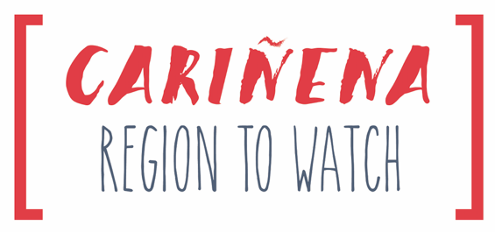

D.O.P. Cariñena Brings the Global Garnacha Experience to VinExpo New York
Historic birthplace of Garnacha will host a Regional Pavilion and Master Class with Pedro Ballesteros, MW
**Click here for a complete schedule of VinExpo events**

NEW YORK, N.Y. (January 15, 2019) – The Spanish wine region of Cariñena, the historic birthplace of Garnacha, will sponsor VinExpo New York in March 2019 as a highlight of their Garnacha Road Tour. D.O.P. Cariñena has enlisted renowned Spanish wine expert, Pedro Ballesteros, Master of Wine, to lead a VinExpo Master Class on Garnacha from Cariñena and other regions, and will also present the wines of Bodegas Paniza, Bodegas San Valero, and Grandes Vinos at a dedicated Pavilion at the VinExpo Grand Tasting.

“Cariñena is in an exciting discovery phase, with a range of styles from unoaked to old vine, Gran Garnacha wines driving a resurgence of interest in the character of their region,” says Pedro Ballesteros, MW. “Through the Garnacha Road Tour the region is dedicated to raising awareness of this increasingly popular variety, which ranks universally high in consumer appeal.” Ballesteros will lead the first VinExpo Master Class on Garnacha, one of several exclusive events offered by the Cariñena region.

Master Class: “Garnacha Unveiled” with Pedro Ballesteros, MW
- Tuesday, March 5th at 10:30 AM (Jacob K. Javits Convention Center, Exhibition Hall 1A)
- Pedro Ballesteros, MW will lead attendees on an exploration of Garnacha from Cariñena and other world wine regions, including varietal characteristics and how leading producers interpret it worldwide. He will also address the grape’s popular resurgence and future prospects, including a comprehensive tasting from rare, old vine to fruit-forward styles.
- RSVP: Reserve a seat at “Garnacha Unveiled” with Pedro Ballesteros, MW

Grand Tasting: Cariñena Exhibitor Pavilion & Club Tasting
- Monday, March 4th and Tuesday, March 5th, 10:00 AM – 6:00 PM (Exhibition Hall 1A: Booths 923, 927, and 1026)
- D.O.P. Cariñena will present a range of wines, including current red, white, and rosé releases from Bodegas Paniza (Booth 923), Bodegas San Valero (Booth 1026), and Grandes Vinos (Booth 927). The Cariñena Exhibitor Pavilion is adjacent to the Wines from Spain booth in Exhibition Hall 1A. Grandes Vinos Anayón Cariñena 2013 will also be featured in the Wine Spectator 90+ Club Tasting Bar, an editor’s selection of exclusive, top-scoring wines.

Schedule an Appointment with Pedro Ballesteros, MW and Regional Representatives
To schedule a private appointment with regional spokesperson Pedro Ballesteros, MW and the participating wineries, please email Stefanie Schwalb or Stephanie Gutierrez. Click here for a full schedule of D.O.P. Cariñena events at VinExpo New York 2019.

